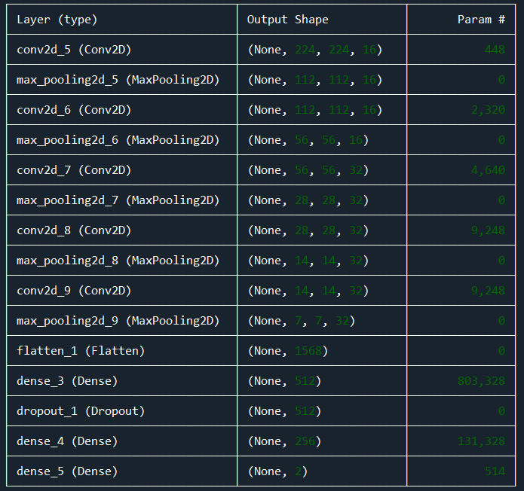

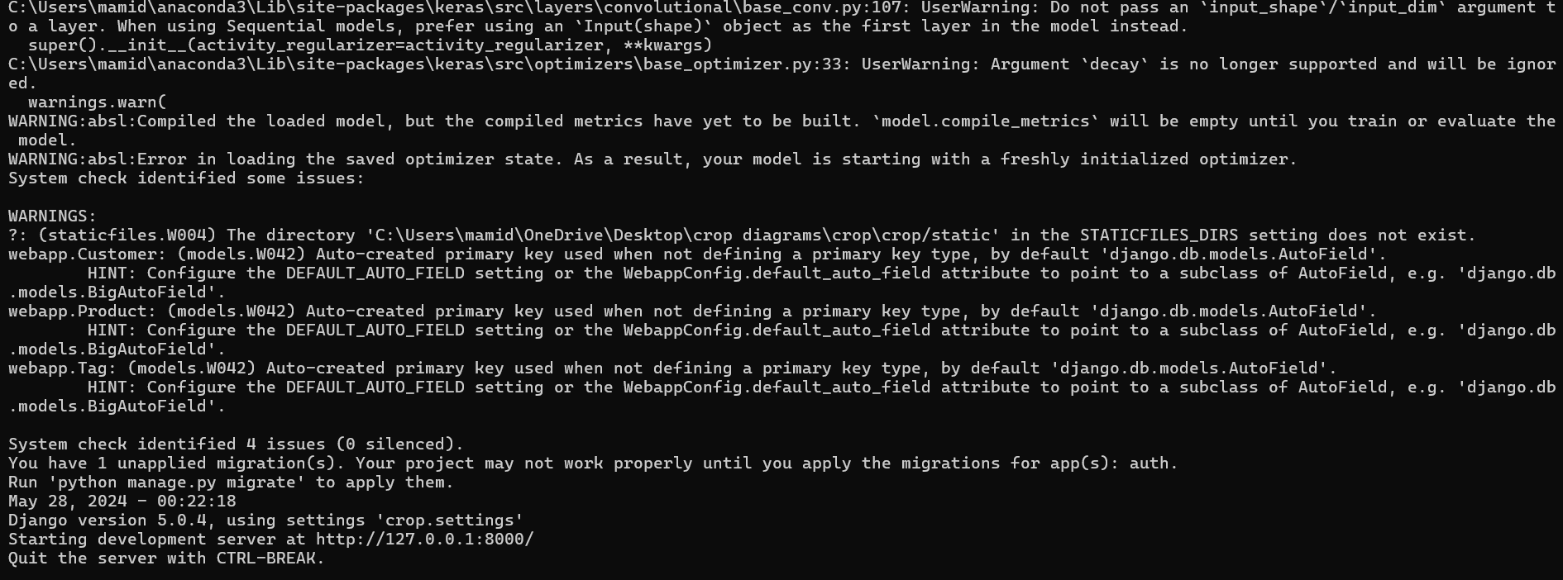

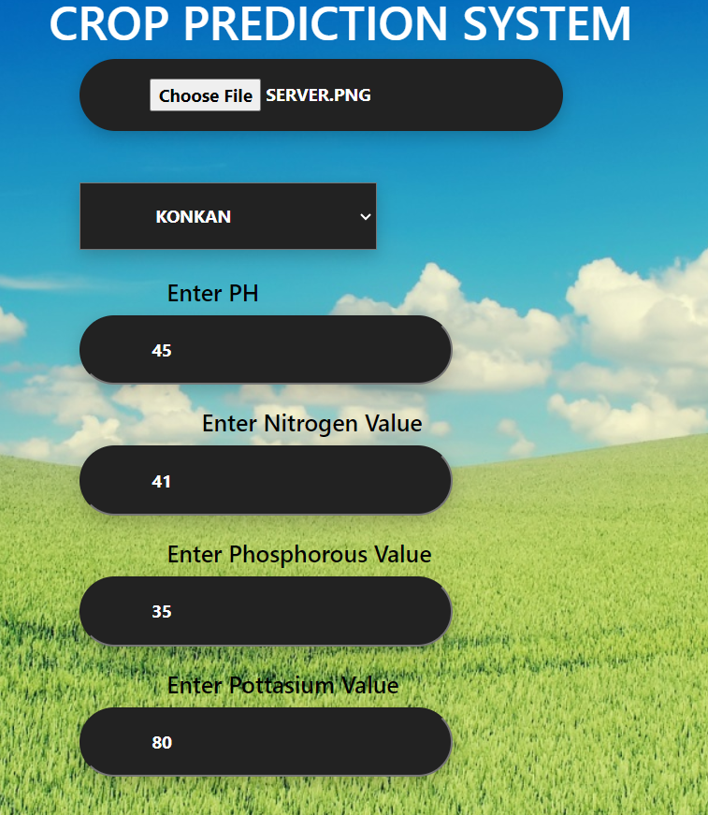



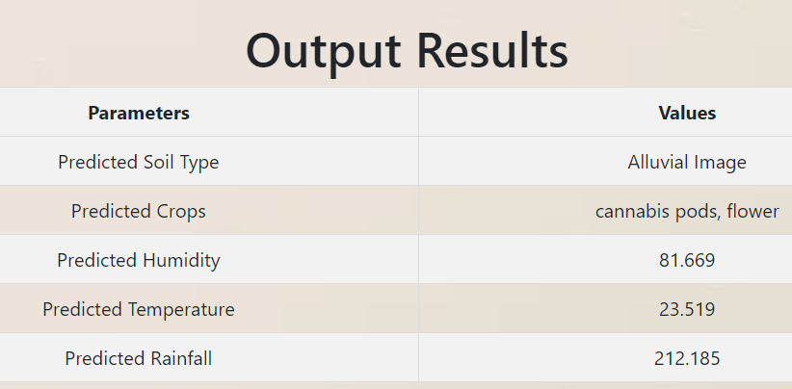



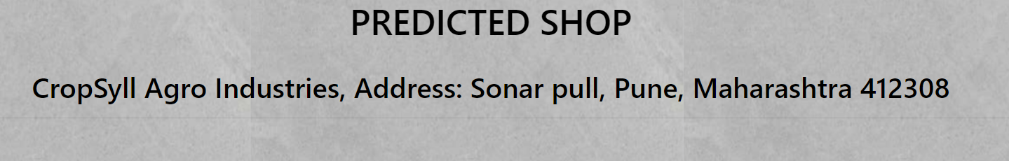

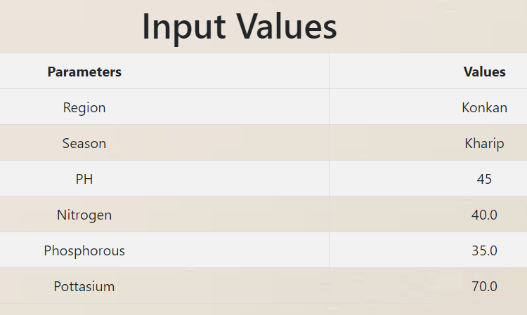

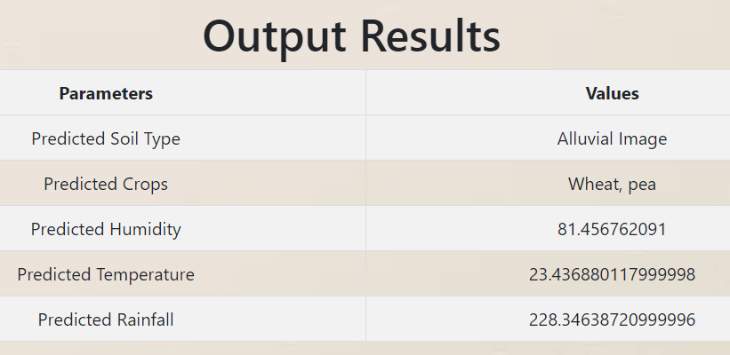

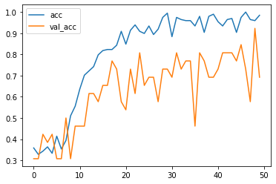

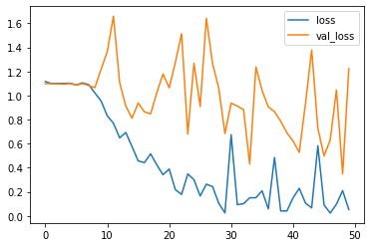

Admin

User

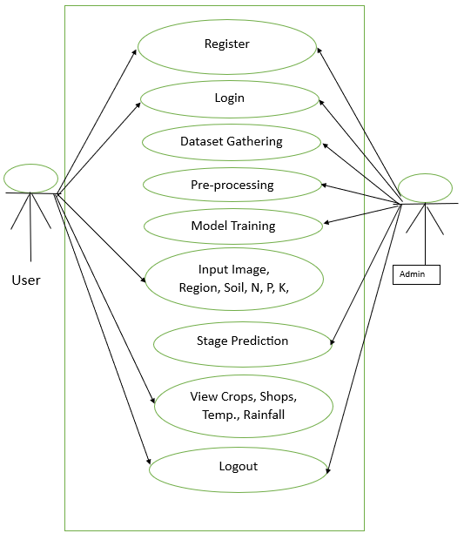

Input Data

Pre-processing

Feature Extraction

Decision

Model Train

Crops Recommend, Temperature, Rainfall, Shops

|  |  |  |  |  |  |  |
| --- | --- | --- | --- | --- | --- | --- |
| **Sr. No** | **Category** | **Samples** | **Training** | **Testing** | **Algorithm** | **Accuracy** |
| 1. | Soil Images | 817 | 656 | 161 | CNN | 98.23% |
| 2. | Crop | 91 | 73 | 18 | RF | 81.25% |
| 3. | Shops | 44 | 39 | 5 | KNN | 99.00% |

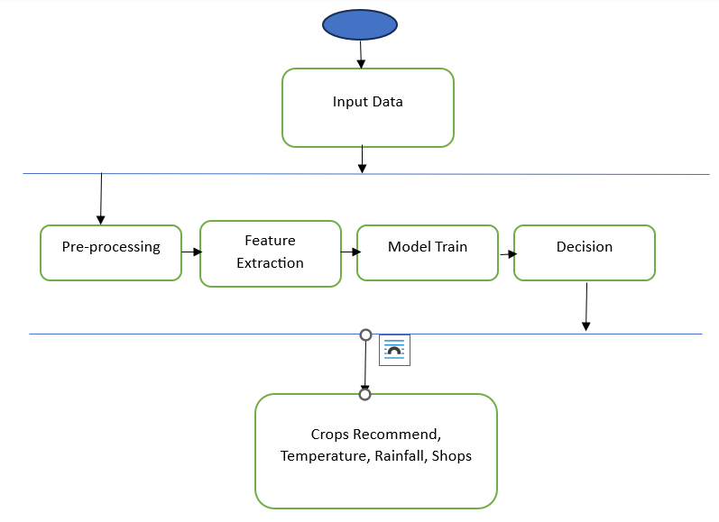

|  |  |
| --- | --- |
| **ABBREVIATION** | **ILLUSTRATION** |
| CNN | Convolutional Neural Network |
| RF | Random Forest |
| KNN | K Nearest Neighborhood |
| SVM | Support Vector Machine |
| AI | Artificial Intelligence |
| ML | Machine Learning |
| ReLu | Rectified Linear Unit |
| pH | Potential of Hydrogen |
| N, P, K | Nitrogen, Phosphorus, Potassium |
| RGB | Red Green Blue |
| Sqrt | Square Root of |
| SLR | Systematic Literature Review |
| SDLC | Software Development Life Cycle, |